**POWER BI ASSIGNMENT – 20**

**Topic-**Charts

**Exercise**-Create date and normal slicers on one page to affect visuals on other pages.

Step 1- Insert three slicers in the choices page as shown below.

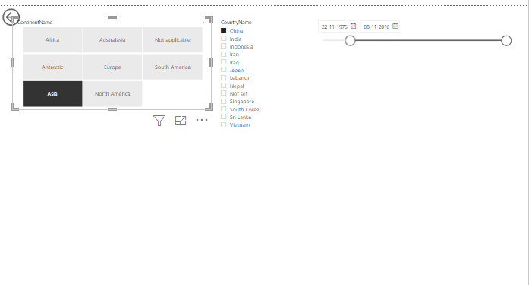

Step-2: Sync slicers to the remaining pages as shown below.

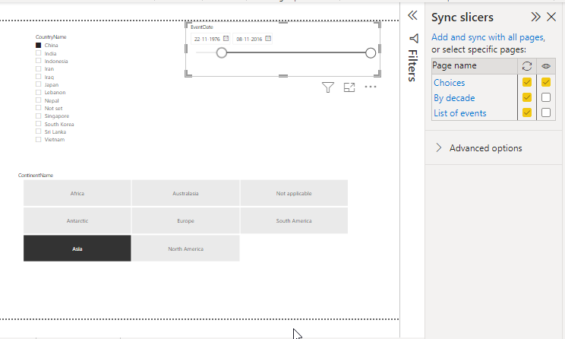

Step -3.Now we can apply slicers values will changes in the other two pages.

